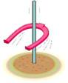 NEWS & MESSAGES
06/05

Completion Rate

J/YR World Championship, Bahrain 2005

by Hervé Ménager, France
and Suzanne Dollinger

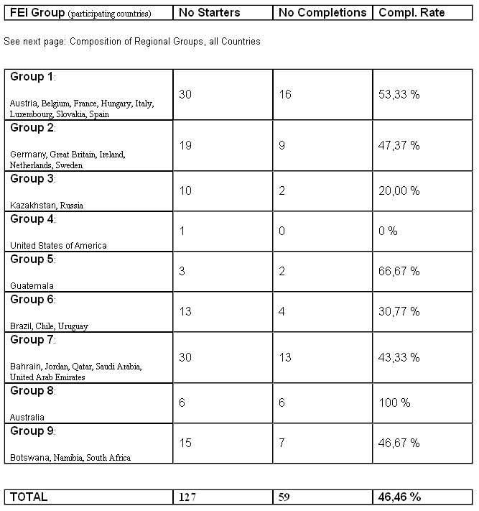

National Federations: Regional Groups

Group I
Andorra, Austria, Belgium, Croatia, Cyprus, Czech Republic, France,
Greece, Hungary, Israel, Italy, Liechtenstein, Luxembourg, Macedonia,
Malta, Monaco, Portugal, Romania, San Marino, Serbia & Montenegro,
Slovakia, Slovenia,
Spain, Switzerland, Turkey

Group II
Denmark, Estonia, Finland, Germany, Great Britain, Iceland, Ireland,
Latvia, Lithuania, Netherlands, Norway, Poland, Sweden

Group III
Armenia, Azerbaijan, Belarus, Bulgaria, Georgia, Iran, Kazakhstan,
Kyrgyzstan, Moldova, Pakistan, Russia, Turkmenistan, Ukraine, Uzbekistan

Group IV
American Samoa, Antigua, Bahamas, Barbados, Bermuda, Canada, Cayman
Islands, Grenada, Haiti, Jamaica, Suriname, Trinidad-Tobago, United
States of America, Virgin Islands

Group V
Colombia, Costa Rica, Cuba, Dominican Republic, Guatemala, Honduras,
Mexico, Netherlands Antilles, Nicaragua, Panama, Puerto Rico, El
Salvador, Venezuela

Group VI
Argentina, Bolivia, Brazil, Chile, Ecuador, Paraguay, Peru, Uruguay

Group VII
Algeria, Bahrain, Egypt, Jordan, Kuwait, Lebanon, Libya, Morocco, Oman,
Palestine, Qatar, Saudi Arabia, Sudan, Syria,
Tunisia, United Arab Emirates

Group VIII
Australia, China People's Republic, Chinese Taipei, Brunei, Hong Kong,
India, Indonesia, Japan, Korea, Malaysia, Mongolia, Myanmar, New
Zealand, Philippines, Singapore, Thailand

Group IX
Botswana, Congo, Ethiopia, Kenya, Lesotho, Malawi, Mauritius, Namibia,
Senegal, South Africa, Swaziland, Zambia, Zimbabwe

