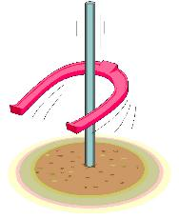 NEWS & MESSAGES
05/05

MEDALS at Open Endurance European Championships 1985 to 2005

European Open Team Medals

1991
1995
2005
1985 | 1999
1989 | 1985 | 1999 | 2001 | 1995
1997 | 1993 | 2001 | 1999 | 1997 | 1987 | 2001 | 1991 | 1993
2003 | 1995 | 2005 | 2003 | 1985 | 2005 | 1997 | 1993 | 1989 | 1991 | 1987 | 2003
FRA | GBR | UAE | POR | GER | BEL | ITA | SWE | SUI | ESP | USA | NED

European Open Individual Medals

1989
1991
1997 |  |  |  |  |  |  |  | Gold
1999 |  |  |  |  |  |  |  | Silver
1989 |  |  |  |  |  |  |  | Bronze
1991 | 2003
1995 | 2005
1997 | 2001
1987 | 2003 | 1993
1989 | 2001 | 1995 | 1985
1995 | 2003 | 1987 | 1987 | 2005
1997 | 2005 | 1993 | 1985 | 1991 | 1999 | 1985 | 1999 | 1993 | 2001
FRA | UAE | GBR | GER | BEL | ESP | AUT | KSA | SWE | ITA

