NEWS & MESSAGES
04/05

MEDALS at Endurance European Championships 1985 to 2005

Team Medals

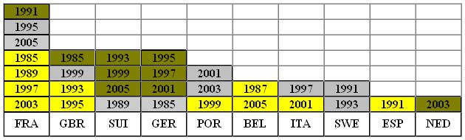

Individual Medals

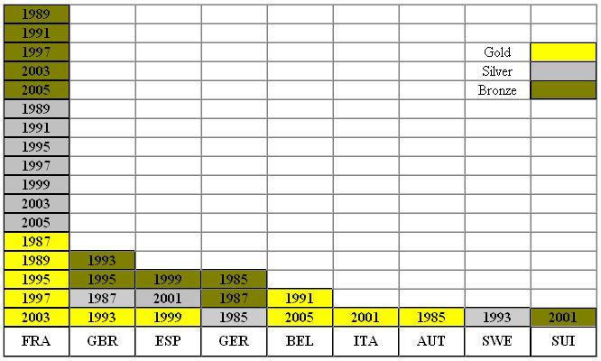

NUMBER OF STARTERS AT Open EUROPEAN CHAMPIONSHIPS

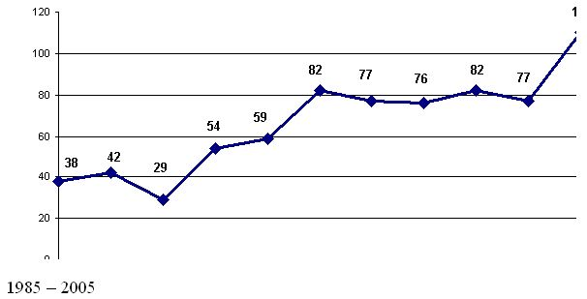

COMPLETION RATE AT Open EUROPEAN CHAMPIONSHIPS in %
1985 – 2005

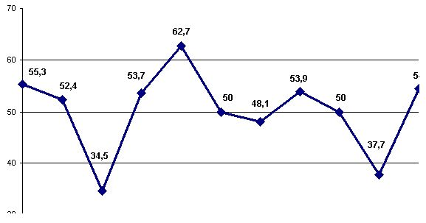

Winner’s SPEED AT Open European CHAMPIONSHIPS in km/h

1985 – 2005

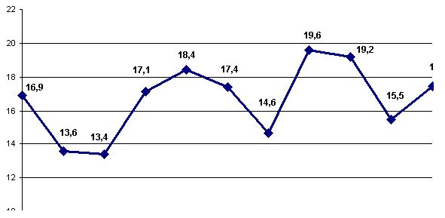

TOP Ten’s AVERAGE SPEED AT Open EUROPEAN CHAMPIONSHIPS
in km/h

1987 – 2005

