ZSAA , PF 1139, D 36209 Alheim

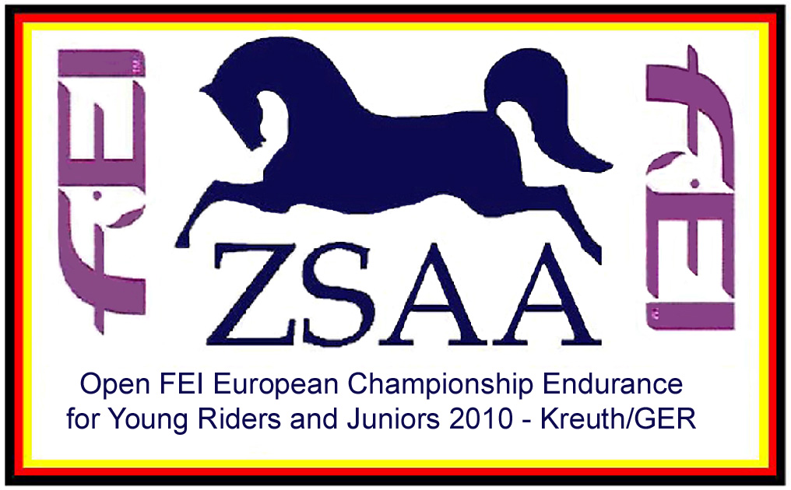

Mai.2009 – AS

CH-EU-YJ-E4* (Open) 120km in Kreuth nr. Rieden, 03.-06.08.2010.

Dear Sirs/Madam,

On behalf of the O.C., ZSAA“ we should like to invite competitors and teams from your country to take part in this event. The schedule for the event is being sent with this letter

The event takes place in Kreuth nr. Rieden in Bavaria, and is part of an international riding-centre there. This Kreuth is near the Czech Border and about 20km south of the town of Amberg the nearest airports are Munich or Nürnberg.

There is a central Vet Gate with 3 different coloured loops. The tracks are mainly fine gravel, grass and forest tracks. The going is firm to hard with some differences in altitude. More information can be found on the web-site www.zsaa.de

Please could you fill in a separate form which is attached or can be downloaded from the web-site to the O.C. giving details of you, your horse, the facilities you require etc. Meals will be provided on site as from 01.08.10, midday. There will be a dinner on the Wednesday night after the opening ceremony on cost of the organisor.

The schedule for the other international rides to be held on 07.08.2010 will be sent to you separately.

Please send in your entries through your FN to the German Federation to Silke Zahel; szahel@fn-dokr.de. Tel.0049-2581-236.

We wish you a safe journey. If you have any questions don’t hesitate to ask us.

With best wishes

