
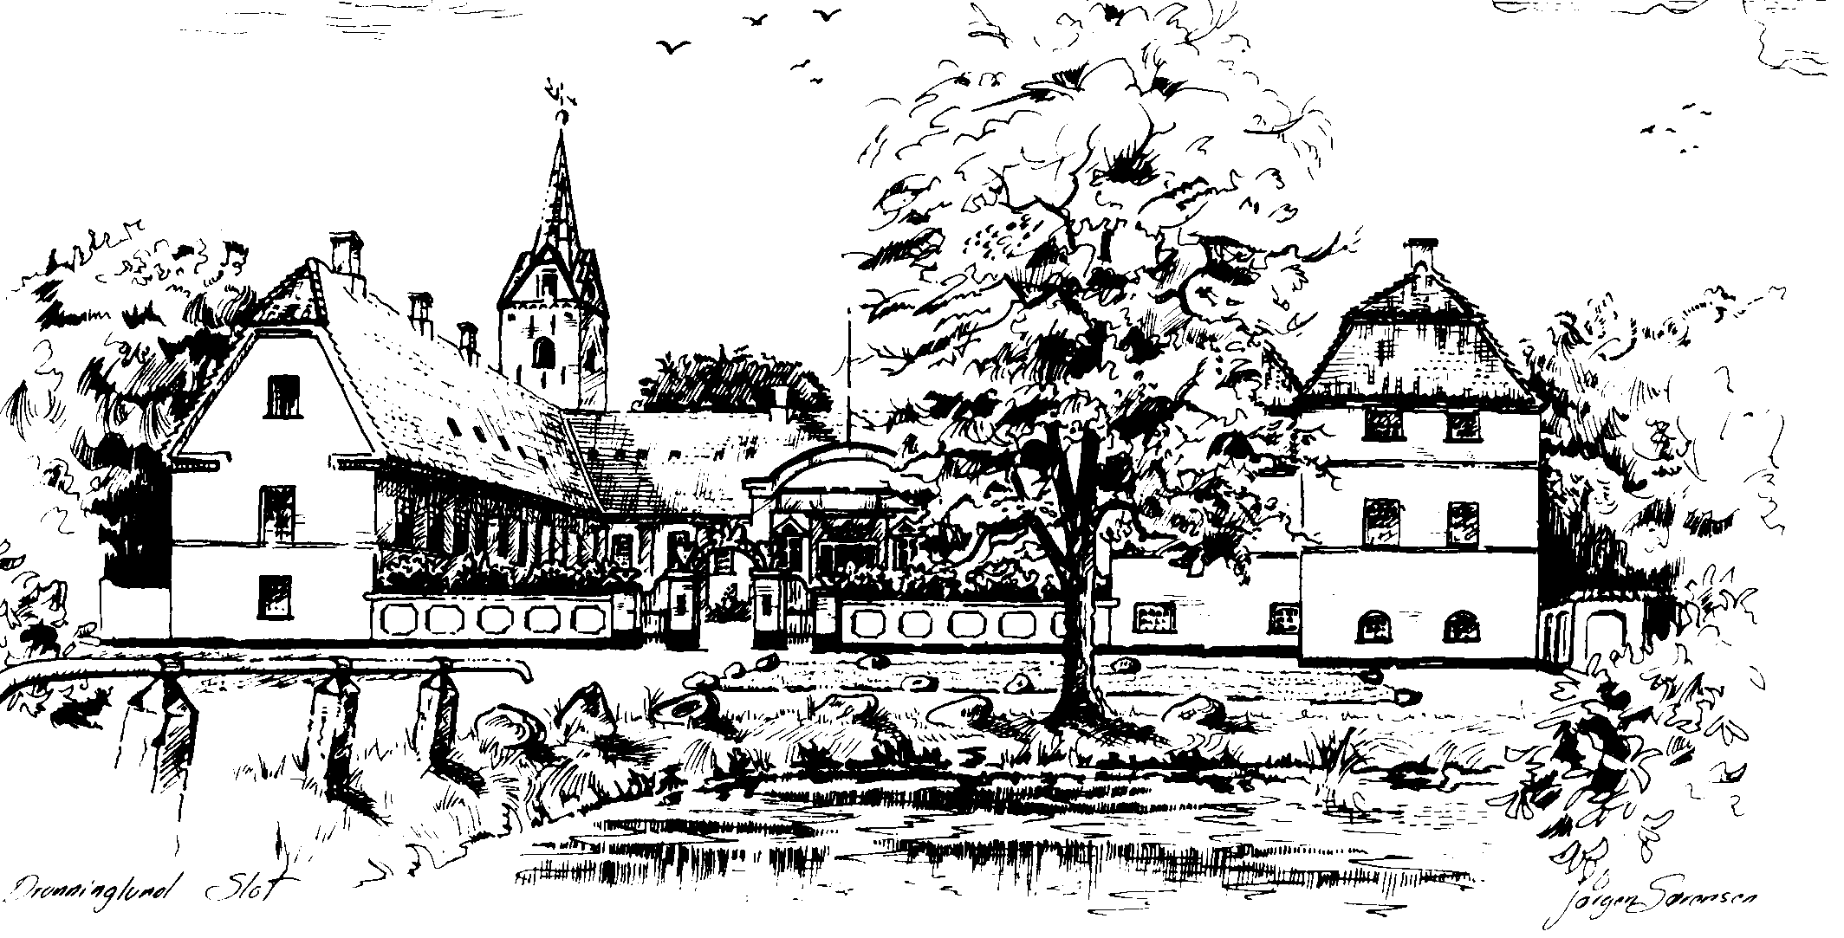

Dronninglund Ridtet 2006

DENMARK

Part one of the Open Danish Young Rider Cup 2006

6th Of MAY 2006

CEIJY1*65km /CEI2*90km /CEI3* 120km/160km

GENERAL CONDITIONS

Please publish the following text verbatim in all Schedules:

This event is organised in accordance with:

- FEI Statutes, 21st edition, revision 2004

- FEI General Regulations, 21st edition, revision 2005

- FEI Veterinary Regulations, 9th edition 2006

- The Rules for Endurance Riding, 6th edition 2005

- New Star Categorisation for Endurance, effective 1st January 2005

- And all subsequent corrections and modifications to the above Rules and Regulations as published by the FEI.

An arbitration procedure is provided for in the FEI Statutes and General Regulations referred to above. In accordance with this procedure, any appeal against a decision rendered by the FEI or its official bodies is to be settled exclusively by the Court of Arbitration for Sport (CAS) in Lausanne, Switzerland.

******************************************************************

CEI 1* - ONE DAY EVENTS
CLASSES | ETOILES | KM
CEI | 1* | 40
CEI | 1* | 50
CEI | 1* | 60
CEI | 1* | 70
CEIJYR | 1* | 40
CEIJYR | 1* | 50
CEIJYR | 1* | 60
CEIJYR | 1* | 70

CEI 2* - ONE DAY EVENTS
CLASSES | ETOILES | KM
CEI | 2* | 80
CEI | 2* | 90
CEI | 2* | 100
CEI | 2* | 110
CEIJYR | 2* | 80
CEIJYR | 2* | 90
CEIJYR | 2* | 100
CEIJYR | 2* | 110

CEI 3* - ONE DAY EVENTS
CLASSES | ETOILES | KM
CEI | 3* | 120
CEI | 3* | 130
CEI | 3* | 140
CEI | 3* | 150
CEI | 3* | 160 and +
CEIO | 3* | 160
CEIJY | 3* | 120
CEIOJY | 3* | 120

CEI 4* - ONE DAY EVENTS
CLASSES | ETOILES | KM
CEI-CH | 4* | 160
CEIJY-CH | 4* | 120

CEI 2* - 2 DAYS OR MORE EVENTS
CLASSES | ETOILES | KM
CEI | 2* | 80 + (2)
CEIJY | 2* | 80 + (2)

CEI3 * - 2 DAYS OR MORE EVENTS
CLASSES | ETOILES | KM
CEI | 3* | 160 + (2)

- GENERAL INFORMATION

  - DENOMINATION OF THE EVENT (Please refer to page 3)
Status (Art. 824): CEI2* x Km 90
CEI3* x Km 160 / CEI3* x Km 120
CEIJY1* x Km 65km

Place: Dronninglund
Country: Denmark
Dates: 05/05-06 – 07/05-06

  - ORGANISER (Complete Address)
Name: Dronninglund Rideklub
Address: Bellisvelj 7
9330 Dronninglund
Denmark
Phone: +4598842261 Fax: +4598842261
Email: alkolind@stofanet.dk
Website: www.DRLR.dk

  - ORGANISING COMMITTEE (Art. 101.6)
President of the Event: Randi Elbo Jensen
Email: Stald-elbo@stofanet.dk
Show Secretary: Lars Kolind

- OFFICIALS (For duties of officials, see Art. 822)
(Name et nationality)

- GROUND JURY (Art. 148, 153, 822)
President: Lars Kolind, Denmark
Level: 4*
Email: alkolind@stofanet.dk
Members: Bente Heggedal Norway
Level: 4*
Members: Birger Nielsen, National, Denmark

- TECHNICAL DELEGATE (FOREIGN) (Art. 156, 157, 822)
(For CEI 4* and Championships the DT must be foreign)
Name: Lone AAlekjær Hansen, Denmark
Level: 4* x
Nationality: Danish
Email: laa@scanjour.dk

- APPEAL COMMITTEE (Art. 154, 164, 822)

- CHIEF STEWARD (Art. 144, 908)
(Must be selected from the FEI Directory, list of Chief Steward for Endurance)
Name: Leif Bagger
Nationality: Danish
Email: tobagger@nrdc.dk

- STEWARDS (Art. 144, 908)
Name: Brian Pedersen
Name: Vagn Joergensen

VETERINARY COMMISSION / DELEGATE (Art. 158, 823, 1003, 1007, 1008, 1009)
President: Line Skadelund, Den
Level: 4*

Foreign Veterinary: Claudia Zerlich,
Nationality: Germany
Level: 4*

Associate Member(s): (one member for 15 horses)
Jette Madsen, Den Level: 3*
Mette Bagger,Den Level:
Ove Andresen,Den Level:
Rikke Rosengaard, Den Level:

- SPECIFIC TECHNICAL CONDITIONS

- COMPETITION (Art. 821. 808. 806. 801) CEI 3* 160km

Individual Individual
Time limit 16Hours
Starting method Mass start
Type of Ground open land, forest with heavy raises
Altitude differentials 0-140m

- MINIMUM DISTANCE PER DAY
Km 160 Number of phases (2 à 6) 6
Vet Gates
Km 30 Into a hold of 30 min.
Km 65 Into a hold of 45 min.
Km 93 Into a hold of 30 min.
Km 130 Into a hold of 45 min.
Km 140 Into a hold of 30 min.
Km 160 Into a hold of min.
(at least one timed hold not shorter than 40 minutes)
For all 160Km rides must have min. 5 Vet gates.
Where compulsory re-examinations required hold time may be increased an extra 10 minutes.

- HEART RATES
At each Vet Check the pulse rate must not exceed 64 after 30 minutes recovery.

- MINIMUM WEIGHT
(no minimum weight for Children, Juniors and Young Riders competitions)
Kg 75
Weighing method ELECTRIC SCALE
5, PLACE AND TIME OF START
Place Dronninglund Rideklub
Time 05:00AM

- COMPETITION (Art. 821. 808. 806. 801) CEI 3* 120km

Team Individual Individual
Time limit 12Hours
Starting method Mass start
Type of Ground open land, forest with heavy raises
Altitude differentials 0-140m

- MINIMUM DISTANCE PER DAY
Km 120 Number of phases (2 à 6) 4
Vet Gates
Km 28 Into a hold of 30 min.
Km 65 Into a hold of 45 min.
Km 95 Into a hold of 30 min.
Km 120 Into a hold of min.
(at least one timed hold not shorter than 40 minutes)
For all 160Km rides must have min. 5 Vet gates.
Where compulsory re-examinations required hold time may be increased an extra 10 minutes.

- HEART RATES
At each Vet Check the pulse rate must not exceed 64 after 30 minutes recovery.

- MINIMUM WEIGHT
(no minimum weight for Children, Juniors and Young Riders competitions)
Kg 75
Weighing method ELECTRIC SCALE

- PLACE AND TIME OF START
Place Dronninglund Rideklub
Time 05:30AM

1.COMPETITION (Art. 821. 808. 806. 801) CEI 2* 90km

Individual Individual
Time limit 10Hours
Starting method Mass start
Type of Ground open land, forest with heavy raises
Altitude differentials 0-140m

- MINIMUM DISTANCE PER DAY
Km 90 Number of phases (2 à 6) 3
Vet Gates
Km 30 Into a hold of 30 min.
Km 65 Into a hold of 45 min.
Km 90 Into a hold of min.
(at least one timed hold not shorter than 40 minutes)
For all 160Km rides must have min. 5 Vet gates.
Where compulsory re-examinations required hold time may be increased an extra 10 minutes.

3. HEART RATES
At each Vet Check the pulse rate must not exceed 64 after 20 min.recovery.

4. MINIMUM WEIGHT
(no minimum weight for Children, Juniors and Young Riders competitions)
Kg 70
Weighing method ELECTRIC SCALE

5.PLACE AND TIME OF START
Place Dronninglund Rideklub
Time 06:00AM

1.COMPETITION (Art. 821. 808. 806. 801) CEIJYR 1* 65km

Team Individual Individual
Time limit 6:30 Hours
Starting method Mass start
Type of Ground open land, forest with heavy raises
Altitude differentials 0-140m

- MINIMUM DISTANCE PER DAY
Km 65 Number of phases (2 à 6) 3
Vet Gates
Km 25 Into a hold of 30 min.
Km 15 Into a hold of 45 min.
Km 25 Into a hold of min.
(at least one timed hold not shorter than 40 minutes)
For all 160Km rides must have min. 5 Vet gates.
Where compulsory re-examinations required hold time may be increased an extra 10 minutes.

3. HEART RATES
At each Vet Check the pulse rate must not exceed 56 after 20 min.recovery.

4. MINIMUM WEIGHT
(no minimum weight for Children, Juniors and Young Riders competitions)
Kg No minimum
Weighing method

5.PLACE AND TIME OF START
Place Dronninglund Rideklub
Time 06:30AM

- LOGOS
allowed

- INVITATIONS

- Championships & CEIOs
Please refer to Art. 826

- CEIs
Country invited OPEN
Number of competitors per country OPEN
Number of horses per competitor/country 1

- CLOSING DATES OF ENTRIES (Art. 121)

Competitors wishing to compete in an International Event must be provided with a confirmation signed by their NF. (Competitors must be entered for International competitions by their NF). Organising Committees may not accept any other entries.

- SCHEDULE OF SUBMISSION (Art. 121)
(Compulsory for CEIOs and Championships only)
Entries in Principle 06-03-2006
Nominated Entries 22-03-2006
Definite Entries 19-04-2006

- EXPENSE & PRIVILEGES (Art. 132,133, 826.5)
Please specify travel, style of accommodation, length of time they are at the expense of the organiser and any compensation scheduled for the following:

The OC will not cover any travel and accommodation costs

- COMPETITORS/CHEFS D’EQUIPE (where applicable)
Accommodation for competitors and grooms
Dronninglund Hotel +4598841533 (Distance from stable 3km)
Dronninglund Slot +4598843300 (Distance from stable 30m)
Camping near stable
Rent a caravan Friday to Sunday 750Dkr. 250Dkr/day for ekstre days
Camping Capins,Aså Camping +4598851340
Futher information contact OC +4598842261/mobil +4527113288

- GROOMS
See a)

- HORSES
Specify transport, stabling, feeding, period of time covered
Stable open from04-05-2006 (evening)to 07-05-2006

- ENTRY FEE CEI 3* 160km 1.525,00Dkr All included
CEI 3* 120KM 1.475,00Dkr. All included
CEI 2* 90km 1.325,00Dkr. All included
CEIJYR1*65KM 1.02500,00Dkr. All included

- GENERAL CLASSIFICATION (Art. 128,129,130,833)
If a general classification is scheduled please give details on method of allocation, amount of cash prizes and/or type of prizes in kind along with the value of the prizes in kind. Total value of first place prize may not exceed 1/3 of the total prize money. The minimum number of prizes offered for each competition must be allocated on the basis of one prize for every commenced four competitors, with a minimum of five prizes.
CEI 3* 160km

TOTAL AMOUNT 5600 Dkr

1st Value 1300 dkr2nd Value 1000Dkr3rd Value 800Dkr4th value 600Dkr
5th Value 400 dkr

Best condition prize: Yes Amount : 1500 Dkr

CEI 3* 120km

TOTAL AMOUNT 4300 Dkr

1st Value 1000 dkr2nd Value 800Dkr3rd Value 600Dkr4th value 500Dkr
5th Value 400 dkr

Best condition prize: Yes x Amount : 1000 Dkr

CEI 2* 90km

TOTAL AMOUNT 3450 Dkr

1st Value 800 dkr2nd Value 600Dkr3rd Value 450 Dkr4th value 350 Dkr
5th Value 250 dkr

Best condition prize: Yes x Amount : 1000 Dkr

CEIJYR 1* 65km

TOTAL AMOUNT 3450Dkr

1st Value 800 dkr2nd Value 600Dkr3rd Value 450 Dkr4th value 350 Dkr
5th Value 250 dkr
best condition prize: Yes x Amount : 1500 Dkr

- AWARDS
An award must be given to all competitors who complete the ride. Please describe awards to be distributed.
Diploma

VETERINARY MATTERS (Art. 1011, 830,830.1.2. 830.5.1-4, 831)

- VETERINARY EXAMINATION
Date 05-05-2006 Time 05:00PM

- FIRST INSPECTION
Date 05-05-2006 Time 05:00PM

- FINAL INSPECTION
Date 07-05-2006 Time 07:30AM

- BEST CONDITION AWARD
Date 07-05-2006 Time 09:00AM

- TREATING VETERINARIAN AT THE EVENT
CEI4* one treating vet per 20 horses, CEI3* one treating vet per 30 horses, CEI2*/1* one treating vet per 50 horses
Name: Dronninglund Dyrklægerne

Name: Hans Karkov

The treating vet may not be a member of the Veterinary Commission

- MEDICATION CONTROL LABORATORY
Details of FEI listed laboratory appointed to carry out analyses on samples collected at this event (Vet Regs. Art 1021 and FEI Bulletin)
Name: Dr. Yves Bonnaire, Labotorie des Courses Hippiques (LCH)
Address: 15 Rue de Paradis, 91370 Verri’eres le Buisson,
France

Phone: (331) 69752828 Fax: (331) 69752830
Email

- NAME OF DOCTOR/MEDICAL SERVICE

Name: Lægehuset +45 98 84 18 88, Emergency +45 112

- NAME OF FARRIER

Name: Torben Enghaven +45 20 88 86 71

Approved by the FEI under the conditions, corrections made above.

CEI3*(160km)/CEI3*(120KM)/CEI2*(90KM)/CEIJY1*(65KM)- DRONNINGLUND (DEN) 05-07.05.06



Date: 14.02.06 Signature : ________________________
Ian Williams
Manager
Department Endurance

APPENDIX IS PART OF THIS APPROVED AND SIGNED FEI DRAFT SCHEDULE

