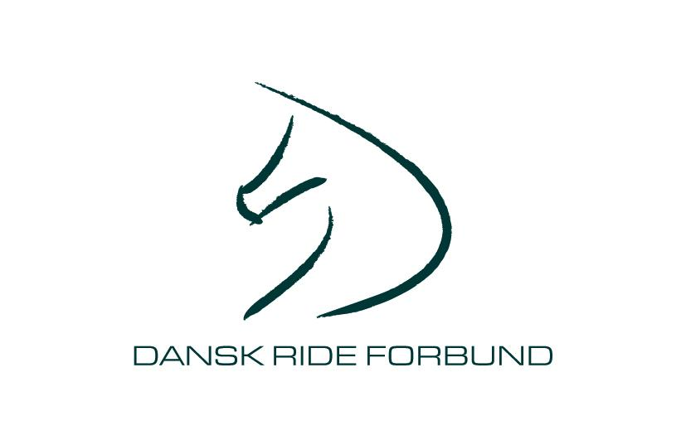

To: Austria, Belgium, Bulgaria, Croatia, Czech Republic, Estonia, Finland, France, Germany, Great Britain, Hungary, Ireland, Italy, Latvia, Lithuania, Netherlands, Norway, Poland, Portugal, Russia, Slovakia, Spain, Sweden, Switzerland

22nd February 2006
Dear Sirs and Madams

Dronninglund Ride 6th May 2006

On behalf of the Organising Committee, the Danish Equestrian Federation, has the pleasure in inviting riders from your country to participate at the CEI/ Y/1/2/3* in Dronninglund. Denmark.

CEI3* 160 km
CEI3* 120 km
CEI2* 90 km
CEI1*/CEIY* 65 km

Please find enclosed a copy of the FEI Schedule

We look forward to receiving your entries as soon as possible.

Entries in principle 6th March
Nominated entry 22nd March
Definite entry 19th April

Kind regards

Merete Fohlmann

Entries are send to: Lars Kolind
Bellisvelj 7, 9330 Dronninglund, Denmark
Phone: +45 98 84 22 61
Fax: +45 98 84 22 61
Email: alkolind@stofanet.dk

Copy to: Danish Equestrian Federation
Merete Fohlmann
Phone: +45 43 26 28 18
Fax: +45 43 26 28 12
Email: mf@fohlmann.dk

